Pupil premium strategy statement

Before completing this template, you should read the guidance on using pupil premium.

Before publishing your completed statement, you should delete the instructions (text in italics) in this template, including this text box.

This statement details our school’s use of pupil premium (and recovery premium for the 2021 to 2022 academic year) funding to help improve the attainment of our disadvantaged pupils.

It outlines our pupil premium strategy, how we intend to spend the funding in this academic year and the effect that last year’s spending of pupil premium had within our school.

School overview
Detail | Data
School name | Ellesmere Port Christ Church C of E Primary School
Number of pupils in school | 210
Proportion (%) of pupil premium eligible pupils | 21%
Academic year/years that our current pupil premium strategy plan covers (3 year plans are recommended) | 2023-2026
Date this statement was published | September 2023
Date on which it will be reviewed | July 2024
Statement authorised by
Pupil premium lead | Laura Owen
Governor / Trustee lead | Gill Foster
Funding overview
Detail | Amount
Pupil premium funding allocation this academic year
Recovery premium funding allocation this academic year
Pupil premium funding carried forward from previous years (enter £0 if not applicable) | £0
Total budget for this academic year
If your school is an academy in a trust that pools this funding, state the amount available to your school this academic year

Part A: Pupil premium strategy plan

Statement of intent
Our philosophy
We believe in maximising the use of the pupil premium grant (PPG) by utilising a long-term strategy aligned to the SDP. This enables us to implement a blend of short, medium and long-term interventions, and align pupil premium use with wider school improvements and improving readiness to learn.
Overcoming barriers to learning is at the heart of our PPG use. We understand that needs and costs will differ depending on the barriers to learning being addressed. As such, we do not automatically allocate personal budgets per pupil in receipt of the PPG. Instead, we identify the barrier to be addressed and the interventions required, whether in small groups, large groups, the whole school or as individuals, and allocate a budget accordingly.
Our priorities
Setting priorities is key to maximising the use of the PPG. Our priorities are as follows:
- Ensuring quality first teaching in all classes
- Closing the attainment gap between disadvantaged pupils and their peers
- Ensuring that attainment at the end of KS2 at least achieves their own projected target
- Providing targeted academic support for pupils who are not making the expected progress
- Where disadvantaged pupils have SEND needs, their provision will be carefully considered
- Attendance of disadvantaged pupils is above 95%
- Addressing non-academic barriers to attainment such as attendance and behaviour
- Ensuring that the PPG reaches the pupils who need it most
We have taken time to consider strategies that have research based evidence, but also strategies that have been tried and tested.

Challenges

This details the key challenges to achievement that we have identified among our disadvantaged pupils.
Challenge number | Detail of challenge
1 | If the curriculum is not carefully planned and sequenced, pupils may develop gaps in their learning
2 | If pupils have poor Maths and English skills, they may not be able to access and engage lessons within school
3 | Barriers to learning may be linked to SEND
4 | If a pupil is not displaying ready to learn behaviour, they may not engage and learn appropriately.
5 | Pupils with specific early life experiences may have difficulty accessing learning
6 | Pupils may not have attended wider school opportunities that build upon their cultural capital and develop a greater understanding of subject areas
7 | Pupils may not have a language rich home environment
8 | Attendance is low for disadvantaged children and we recognise the need for constant support in this area

Intended outcomes
This explains the outcomes we are aiming for by the end of our current strategy plan, and how we will measure whether they have been achieved.
Intended outcome | Success criteria
For disadvantaged learners to become more secure in Reading, Writing and Maths | Targets for the end of academic year for children to reach ARE (combined)  Y1- 33%  Y2- 60%  Y3- 38%  Y4- 38%  Y5- 55%  Y6- 50%
For 80% of Year 1 children to pass the Phonics Screening check
For children to display effective behaviour for learning | Within lessons and around school pupils will demonstrate our school rules of “ready, respectful and safe”. There will be a reduced number of incidents of heightened behaviours logged on CPoms.
For children to be provided with a wealth of extra curricular activities in order to develop their life experiences, communication skills, resilience and drive | Improved well being and resilience for pupils will be evaluated using: pupil voice, staff voice and behaviour logs.
For attendance of disadvantaged learners to be above 95 % | This will be evidenced through attendance logs

Activity in this academic year
This details how we intend to spend our pupil premium (and recovery premium funding) this academic year to address the challenges listed above.

Teaching
Budgeted cost: £ [insert amount]
Activity | Evidence that supports this approach | Challenge number(s) addressed
Teaching for Mastery project for maths | 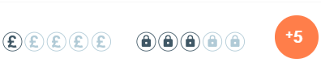 | 1 & 2
The Spelling Book spelling scheme (Jane Considine) | As a school we have found that a lot of our children are not achieving the spelling objectives related to their year group. The barrier of lack of home support for learning spelling was also evident.1 | 1 & 2
Whole class reading CPD |  | 1 & 2

Targeted academic support – structured interventions, small group phonics teaching
Budgeted cost: £18,491
Activity | Evidence that supports this approach | Challenge number(s) addressed
TA small group structured interventions for English and Maths |  | 1, 2, 3 & 7
Focussed phonics groups, reduced in size led by a TA or teacher | 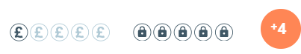 | 1, 2, 3 & 7

Wider strategies (for example, related to attendance, behaviour, wellbeing)
Budgeted cost: £47,936
Activity | Evidence that supports this approach | Challenge number(s) addressed
Attendance and punctuality monitoring- involving certificates, letters home to parents | Attendance for children in receipt of the PPG was 95.5% compared to their peers which was 98% | 4, 5 & 6
Emotional Literacy Support for identified children |  | 4, 5 & 6
Extra curricular sports clubs |  | 6

Total budgeted cost: £ `

Part B: Review of outcomes in the previous academic year

Pupil premium strategy outcomes
This details the impact that our pupil premium activity had on pupils in the 2022 to 2023 academic year.
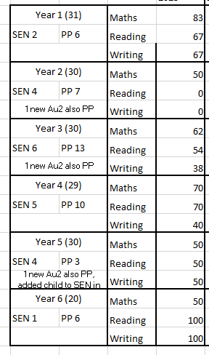

Externally provided programmes
Please include the names of any non-DfE programmes that you purchased in the previous academic year. This will help the Department for Education identify which ones are popular in England
Programme | Provider
Mastering Number | NCETM

Service pupil premium funding (optional)
For schools that receive this funding, you may wish to provide the following information:
Measure | Details
How did you spend your service pupil premium allocation last academic year? | ELSA support where necessary
What was the impact of that spending on service pupil premium eligible pupils?

Further information (optional)
Use this space to provide any further information about your pupil premium strategy. For example, about your strategy planning, or other activity that you are implementing to support disadvantaged pupils, that is not dependent on pupil premium or recovery premium funding.

