Parents Meeting: Year 1 Phonic Screening Check

What can you do to help at home?

- Use ‘Special Friends’, ‘Fred Talk’, read the word, to read words.
- Practise reading sounds speedily - ‘review, review, review’.
- Listen to your child read their Read Write Inc. Storybook every day.

There are free video tutorials on our website – www.ruthmiskin.com

Select ‘Find out more’ at the top, then ‘Parents’ from the drop-down list:

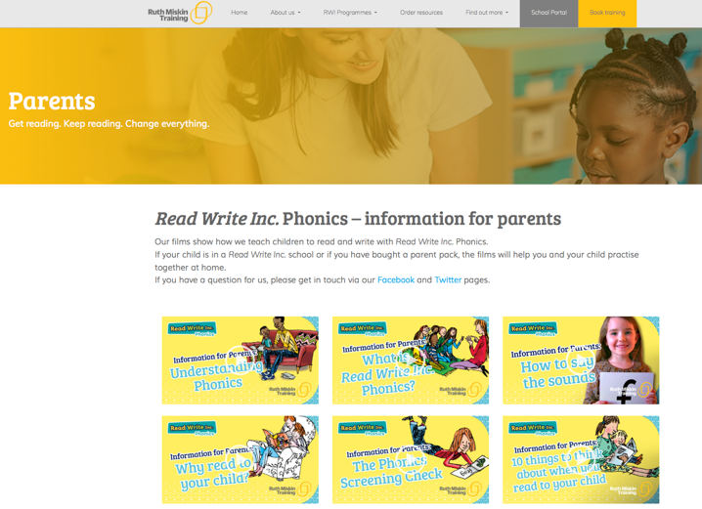

We’re also on Facebook – www.facebook.com/miskin.education

Free e-books for home reading:
http://www.oxfordowl.co.uk/Reading/

